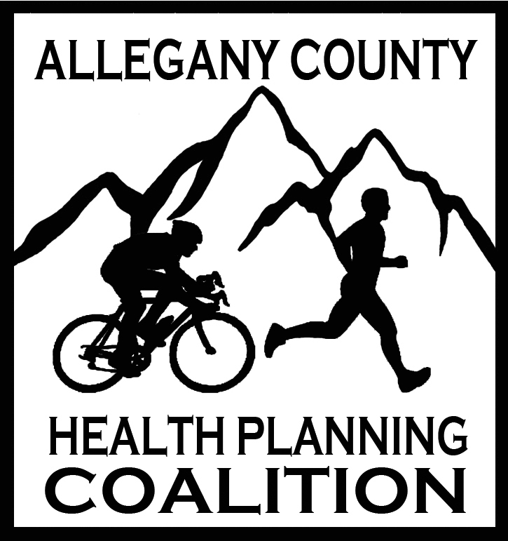

ALLEGANY COUNTY HEALTH PLANNING COALITION
Healthier Together in Allegany County

March 11, 2025 1:30-3:00 PM MS Teams

AGENDA

- Introductions and Welcome!

- Review January 14, 2025, meeting notes

- Presentation:

Healthy Together Program

- Melissa A Clark, MPA, Associate Director,
Maryland Area Health Education Center West (AHEC West)
- Lydia Yoder, Program Coordinator
- David Stewart, Program Director

- Community Health Improvement Plan (CHIP) Updates (previously called Local Health Action Plan)

- CHA – Community Health Assessment

- CHIP – Coalition partners who offer and can report outcomes on programs related to the CHIP priorities are welcome to address those with us at any meeting, or email Melissa Nething, melissaj.nething@maryland.gov, and Stacey Blank, blanksl@upmc.edu

- Community Health Improvement Plan 2022-2025 available on the Allegany County Health Planning Coalition website: Allegany Health Coalition | Allegany County Health Coalition (alleganyhealthplanningcoalition.com)

- UPDATE! Facebook Page -Get Healthy Allegany County – Feel free to share upcoming events to this page

- Updates:

- Cancer Committee – Ellie Folk, Director of Cancer & Tobacco Cessation Programs, ACHD

- Partner Announcements & Updates

- Next Meeting: May 13, 2025 @ 1:30pm

