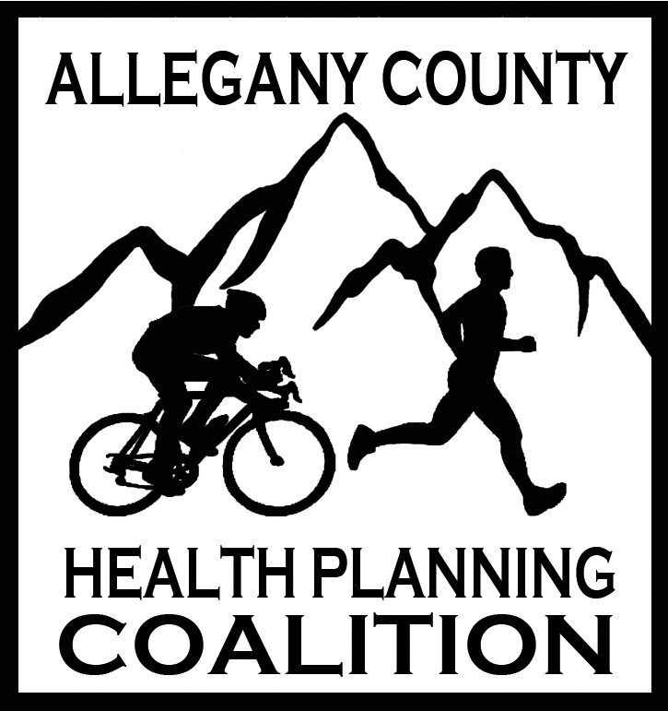

**ALLEGANY COUNTY HEALTH PLANNING COALITION**

*Healthier Together in Allegany County*

March 11, 2025 1:30-3:00 PM MS Teams

**AGENDA**

1. Introductions and Welcome!
2. Review January 14, 2025, meeting notes
3. Presentation:

***Healthy Together Program***

* Melissa A Clark, MPA, Associate Director,

Maryland Area Health Education Center West (AHEC West)

* Lydia Yoder, Program Coordinator
* David Stewart, Program Director

1. Community Health Improvement Plan (CHIP) Updates (previously called Local Health Action Plan)

* CHA – Community Health Assessment
* CHIP – Coalition partners who offer and can report outcomes on programs related to the CHIP priorities are welcome to address those with us at any meeting, or email Melissa Nething, [melissaj.nething@maryland.gov](mailto:melissaj.nething@maryland.gov), and Stacey Blank, [blanksl@upmc.edu](mailto:blanksl@upmc.edu)
* Community Health Improvement Plan 2022-2025 available on the Allegany County Health Planning Coalition website: [Allegany Health Coalition | Allegany County Health Coalition (alleganyhealthplanningcoalition.com)](https://alleganyhealthplanningcoalition.com/)
* **UPDATE!** Facebook Page -***Get Healthy Allegany County*** – Feel free to share upcoming events to this page

1. Updates:

* Cancer Committee – Ellie Folk, Director of Cancer & Tobacco Cessation Programs, ACHD

1. Partner Announcements & Updates
2. Next Meeting: **May 13, 2025 @ 1:30pm**